# **Final Project Report:** Creating an AI Influencer Persona for Social Media Monetization

Team: Analytics Avengers

### 1. Business Objective

* **Objective:** To create an AI-generated influencer persona specializing in food and recipe content on Instagram with the goal of monetizing this persona through strategic brand partnerships and promotions.
* **End Goal:** Establish a monetizable social media presence that leverages high-quality AI-generated content to attract and maintain a large, engaged follower base.

### 2. Key Actionable Business Initiative

* **Development:** Create a virtual influencer using advanced generative adversarial networks (GANs) to produce realistic images of a blonde female engaging with various food items.
* **Launch Strategy:** Initiate an Instagram account featuring this AI influencer, strategically posting generated content to build followership and engagement.
* **Engagement Strategy:** Utilize data-driven insights to tailor content, optimize posting times, and interact effectively with the target audience.

### 3. Metrics of Success

* **Primary Metrics:** Follower Growth Rate, Engagement Rate (likes, comments, shares), and Revenue from Sponsorships.
* **Hypothesis:** Implementing a unique, high-quality AI-generated influencer will lead to above-average engagement rates and open substantial monetization opportunities through brand collaborations and sponsorships.
* **Evaluation:** Regular assessment of growth and engagement metrics against set benchmarks to gauge success and adjust strategies accordingly.

### 4. Role of Analytics

* **Enablement:** Analytics will help identify the most engaging types of content and optimal posting times to maximize follower interaction and growth.
* **Ideation:** Continuous analysis of engagement metrics will guide content refinement and strategy adjustments.
* **Evaluation:** Analytics will evaluate the success of the AI influencer in terms of follower growth, engagement, and revenue generation.

### 5. Thinking Through the Analytics

* **Data Sources:** Employ a hybrid data collection strategy, combining scraped images with publicly available datasets, and synthesizing these into a training set for GANs.
* **Analytical Approaches:** Employ both predictive analytics (to generate and optimize content) and causal analytics (to understand the impact of specific content types on engagement).
* **Impediments and Solutions:** Address potential data quality issues, computational resource limitations, and the realism of AI-generated images by enhancing model training and leveraging cloud computing resources.

### 6. Executing the Analytics

* **Operational Steps:** Outline the detailed steps from data collection, model training on GCP, to real-time analytics for engagement monitoring.
* **Team Responsibilities:** Define clear roles for data scientists (model training), social media managers (content deployment and interaction), and analysts (performance tracking and strategy optimization).
* **Strategic Execution:** Utilize insights derived from analytics to make informed decisions about content scheduling, influencer interaction strategies, and promotional activities.

### 7. Implementation

* **Content Strategy:** Based on analytics, adjust content creation and posting schedules to maximize engagement and follower growth.
* **Partnership Decisions:** Use engagement data to attract and negotiate with brands that align with the followers’ interests, maximizing sponsorship revenue.
* **Workflow Integration:** Ensure that analytics insights are seamlessly integrated into daily operations, enhancing decision-making processes and strategic planning.

### 8. Scale

* **Organizational Challenges:** Address potential challenges related to data management, team skills, system capabilities, and organizational culture.
* **Solutions and Growth Plans:** Develop a robust infrastructure for data handling, provide ongoing training for team members, and advocate for a data-centric culture within the organization.
* **Continuous Improvement and Feedback Loop:** Establish mechanisms for regular feedback and continuous improvement in strategies based on analytics, maintaining agility to adapt to changing trends and follower preferences.
* **Pros and Cons Analysis:** Dive deeper into the advantages of scalability and time efficiency offered by an AI influencer, while also critically assessing the challenges of authenticity and technical limitations in AI-generated content.

### 9. Methodology and Steps

#### Step 1: Data Collection

We started by scraping images from Getty Images. We collected 5,000 images of blonde females and 5,000 images of food items. The images were stored in Google Drive for easy access and management.

#### Step 2: Data Storage

The collected images were stored in Google Drive, organized into folders for blonde female images and food images. This facilitated efficient access and management of the dataset.

#### Step 3: Preprocessing

The preprocessing involved resizing all images to 128x128 pixels and normalizing the pixel values to a range of [-1, 1]. This standardized the input data for training our GAN models.

#### Step 4: Setting Up Colab Environment

We utilized Google Colab with a T4 GPU runtime for training our models. This setup provided the necessary computational power and ease of access to our Google Drive-stored datasets. The Colab environment was configured by mounting Google Drive and installing the required Python packages.

#### Step 4: Model Training

We trained three different GAN models to generate the desired images:

**First Model:**

The first model used a standard Generative Adversarial Network (GAN) architecture. The generator was designed to create 128x128 pixel images of blonde female portraits from random noise, while the discriminator distinguished between real and generated images. Despite extensive training, this model struggled to produce high-quality, realistic images.

**Second Model:**

The second model implemented a Wasserstein GAN with Gradient Penalty (WGAN-GP) to improve training stability and image quality. This model was also trained on blonde female portraits. The generator and critic (a replacement for the discriminator in WGANs) architectures were enhanced with additional layers and lower learning rates. The gradient penalty was used to enforce Lipschitz continuity, crucial for WGAN training. Although this model showed some improvements, the generated images still lacked the desired level of realism and detail.

**Third Model:**

The third model combined the datasets of blonde female portraits and food images to generate diverse outputs. The dataset was shuffled to ensure the GAN received a mix of both categories during each training iteration. The same GAN architecture as the first model was used, but with the combined dataset. This approach aimed to explore creative combinations of both image categories.

#### Step 6: Evaluating Model Quality

Despite extensive training, the models faced challenges in consistently generating high-quality images. The generated images often lacked the desired realism and detail. This prompted us to consider using more advanced AI tools and techniques to achieve better results.

#### Step 7: Exploring Alternative Tools

To achieve the desired quality and stability, we decided to leverage existing AI tools such as Leonardo AI, which have more advanced capabilities for generating high-quality images.

#### Step 8: Leveraging AI for Instagram

With high-quality images generated using advanced AI tools, we plan to create and manage an Instagram account for the AI influencer. Our strategy includes regular posting, engaging with followers, and leveraging analytics to optimize content and posting schedules.

### 10. Monetization Plan

* **Follower and Engagement Growth:** Focus on organic growth through high-quality content and strategic engagement.
* **Brand Partnerships:** Collaborate with brands for sponsored posts and promotions.
* **Subscription Tools:** Invest in AI tools and analytics subscriptions based on the account's performance and growth metrics.

**Monetization Model**

* Revenue Estimation model = Affected by follower growth rate, engagement rate, average revenue per engagement.

Variables = Number of sponsored posts per month, average earnings per post, affiliate conversion rate, merchandise sales volume.

* Sample Projection (only 1 AI influencer, if someone can manage to have 5 AI influencer/ year they can have added revenue about 250,000$)

**Year 1:** $50,000 (10 sponsored posts/month at $1,300 each, plus $10,000 from affiliate marketing and merchandise)

**Year 3:** $150,000 (20 sponsored posts/month at $2,500 each, plus $30,000 from affiliate marketing and merchandise)

**Comparison Between AI and Real Influencers**

Industry Average: Influencers with 50,000-100,000 followers charge $500 to $5,000 per post, while those with over 500,000 followers can charge upwards of $10,000 per post​.

[Source](https://www.shopify.com/blog/influencer-pricing)

| Criteria | Real Influencers | AI Influencers |
| --- | --- | --- |
| Content Creation | Authentic, human touch, spontaneous | Consistent, high-volume, cost-effective |
| Engagement & Audience Interaction | High personal engagement, relatable | Scalable, consistent positive interaction |
| Cost & Efficiency | Higher costs, time-consuming | Lower cost - highly efficient |
| Market Acceptance | Strong market credibility, viral potential | Growing acceptance, global reach, ethical concerns |

**Comparison Monetization Between Real and AI Influencer**

*Details on the estimation can be found in Appendix*

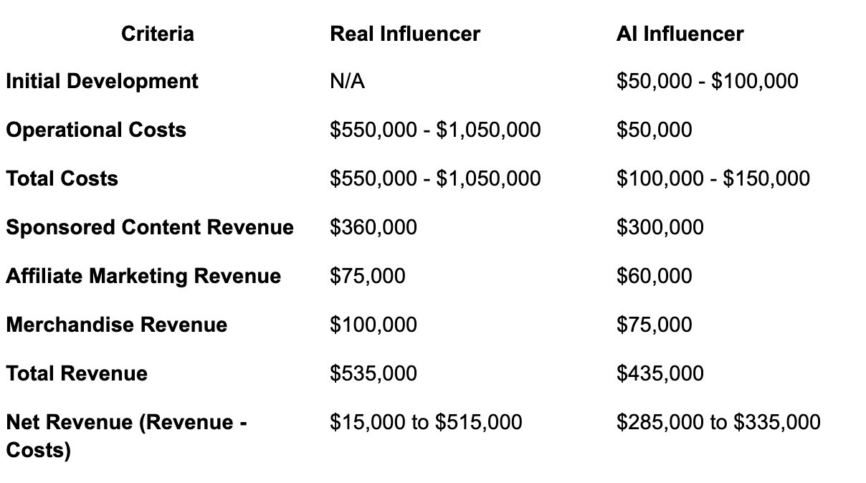

**Related Research for AI Influencer:**

"Unreal Influence: Leveraging AI in Influencer Marketing":

This paper compares consumer responses to AI and human influencers, finding that AI influencers can be as effective as human influencers in certain contexts, despite lower trust levels. It highlights the potential of AI influencers in driving engagement and word-of-mouth​ ([Emerald Insight](https://www.emerald.com/insight/content/doi/10.1108/EJM-12-2019-0949/full/html))​.

"The State of AI in Influencer Marketing: A Comprehensive Benchmark Report":

This report provides insights into the growing adoption of AI in influencer marketing and highlights the significant funding and transformative potential of AI technologies in this space​ ([Influencer Marketing Hub](https://influencermarketinghub.com/ai-in-influencer-marketing/))​.

**APPENDIX**

Projection Estimation

1. **Initial Development:**
   * **AI Influencer:** $50,000 - $100,000
     + **Explanation:** This cost includes the development of the AI model, initial content creation setup, and necessary software and hardware. Developing an advanced AI model, including image and video generation capabilities, can cost around $50,000 to $100,000 based on industry estimates.
     + **Sources:** [Influencermarketinghub.com](http://influencermarketinghub.com), business case studies on AI development costs.
2. **Operational Costs:**
   * **Real Influencer:** $550,000 - $1,050,000
     + **Explanation:** Real influencers incur high operational costs, including production expenses (filmers, editors, copywriters), management fees, travel expenses, and personal maintenance. High-profile influencers can spend up to $1 million annually on these costs.
     + **Sources:** [Hubspot.com](http://hubspot.com), [Shopify.com](http://shopify.com) ([HubSpot Blog](https://blog.hubspot.com/marketing/ai-influencer-marketing)) ([Shopify](https://www.shopify.com/blog/influencer-pricing)).
   * **AI Influencer:** $50,000
     + **Explanation:** Operational costs for AI influencers are significantly lower, covering maintenance, updates, content moderation, and minimal marketing expenses.
     + **Sources:** [Influencermarketinghub.com](http://influencermarketinghub.com), [digitalagencynetwork.com](http://digitalagencynetwork.com) ([Influencer Marketing Hub](https://influencermarketinghub.com/ai-in-influencer-marketing/)) ([Digital Agency Network](https://digitalagencynetwork.com/how-ai-influencers-are-taking-over-social-media/)).
3. **Total Costs:**
   * **Real Influencer:** $550,000 - $1,050,000
   * **AI Influencer:** $100,000 - $150,000
     + **Explanation:** Total costs combine initial development and operational expenses, highlighting the cost efficiency of AI influencers.
4. **Sponsored Content Revenue:**
   * **Real Influencer:** $360,000
     + **Explanation:** Mid-tier influencers (50,000 - 100,000 followers) can earn $500 to $5,000 per post. Assuming 10 sponsored posts per month at an average rate of $3,000 per post, the annual revenue would be $360,000.
     + **Sources:** [Influencermarketinghub.com](http://influencermarketinghub.com), [Shopify.com](http://shopify.com) ([Shopify](https://www.shopify.com/blog/influencer-pricing)) ([Influencer Marketing Hub](https://influencermarketinghub.com/influencer-rates/)).
   * **AI Influencer:** $300,000
     + **Explanation:** AI influencers can generate similar revenue but at slightly lower rates due to perceived lower trust and authenticity. Assuming 10 sponsored posts per month at $2,500 each, the annual revenue would be $300,000.
     + **Sources:** [Influencermarketinghub.com](http://influencermarketinghub.com) ([Influencer Marketing Hub](https://influencermarketinghub.com/ai-in-influencer-marketing/)) ([Boston University](https://www.bu.edu/bhr/2021/10/04/influencer-marketing-a-comparison-of-traditional-celebrity-social-media-influencer-and-ai-influencer/)).
5. **Affiliate Marketing Revenue:**
   * **Real Influencer:** $75,000
     + **Explanation:** Real influencers can earn through affiliate marketing, with commissions typically ranging from 5% to 30%. Assuming moderate conversion rates, they can earn around $75,000 annually.
     + **Sources:** [Influencermarketinghub.com](http://influencermarketinghub.com), [digitalagencynetwork.com](http://digitalagencynetwork.com) ([inBeat](https://www.inbeat.co/articles/influencer-rate-sheet/)) ([Digital Agency Network](https://digitalagencynetwork.com/how-ai-influencers-are-taking-over-social-media/)).
   * **AI Influencer:** $60,000
     + **Explanation:** AI influencers can also generate revenue through affiliate marketing but may have slightly lower engagement rates, resulting in estimated earnings of $60,000 annually.
     + **Sources:** [Influencermarketinghub.com](http://influencermarketinghub.com) ([Boston University](https://www.bu.edu/bhr/2021/10/04/influencer-marketing-a-comparison-of-traditional-celebrity-social-media-influencer-and-ai-influencer/)) ([Digital Agency Network](https://digitalagencynetwork.com/how-ai-influencers-are-taking-over-social-media/)).
6. **Merchandise Revenue:**
   * **Real Influencer:** $100,000
     + **Explanation:** Real influencers can sell branded merchandise, such as cookbooks and apparel, leveraging their personal brand to generate around $100,000 annually.
     + **Sources:** [Shopify.com](http://shopify.com), industry case studies ([Shopify](https://www.shopify.com/blog/influencer-pricing)) ([INSG.CO](https://www.insg.co/en/influencer-cost/)).
   * **AI Influencer:** $75,000
     + **Explanation:** AI influencers can also sell branded merchandise but may generate slightly less due to lower perceived authenticity, estimated at $75,000 annually.
     + **Sources:** [Influencermarketinghub.com](http://influencermarketinghub.com), [digitalagencynetwork.com](http://digitalagencynetwork.com) ([Influencer Marketing Hub](https://influencermarketinghub.com/ai-in-influencer-marketing/)) ([Digital Agency Network](https://digitalagencynetwork.com/how-ai-influencers-are-taking-over-social-media/)).
7. **Total Revenue:**
   * **Real Influencer:** $535,000
   * **AI Influencer:** $435,000
     + **Explanation:** Total revenue combines earnings from sponsored content, affiliate marketing, and merchandise sales.
8. **Net Revenue (Revenue - Costs):**
   * **Real Influencer:** $15,000 to $515,000
   * **AI Influencer:** $285,000 to $335,000
     + **Explanation:** Net revenue is calculated by subtracting total costs from total revenue, showcasing the higher profitability of AI influencers due to their lower costs.